Project Design Phase-II
Data Flow Diagram & User Stories
Date | 08 October 2026
Project Name | Implement Client Script & UI Policy (Incident)
Team Id | 9100Byte
Maximum Marks | 4 Marks

Data Flow Diagrams
The Data Flow Diagram for this solution shows how an Incident record moves from user input through Impact-based UI Policy and Client Script controls. When Impact is High, the configured rules make Assignment group mandatory, set Urgency automatically, make Urgency read-only, and validate Assigned To before the record is saved. Direct State editing from the Incident list is also restricted.
DFD Level 0 – Incident Form Control Flow
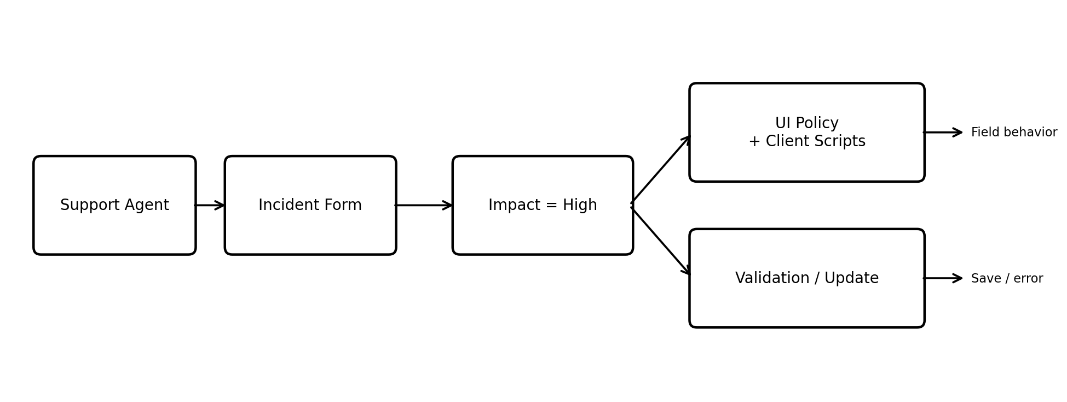
DFD Flow: Support Agent → Incident Form → Impact = High → UI Policy / Client Script Controls → Field Update, Read-only/Mandatory Behavior or Validation Error → Incident Record.
Detailed Control Flow
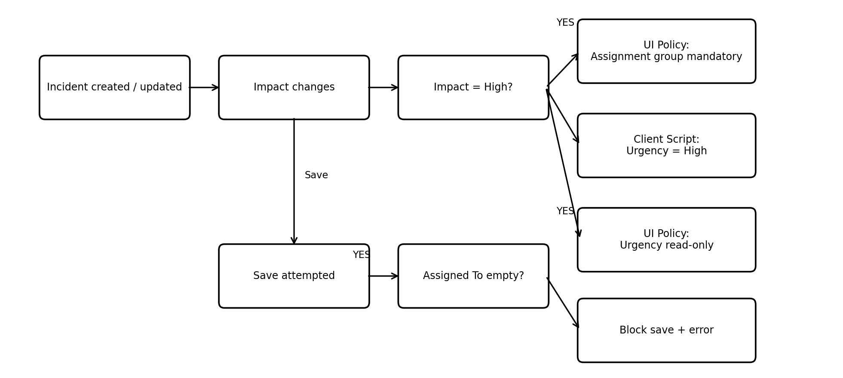

User Stories
Use the below template to list the user stories for the product.
User Type | Functional Requirement (Epic) | User Story Number | User Story / Task | Acceptance Criteria | Priority | Release
Support Agent | Incident UI Policy | USN-1 | As a support agent, I can create/update an Incident so that UI Policy rules are applied when Impact is High. | When Impact = High, Assignment group becomes mandatory and Urgency becomes read-only. | High | Sprint-1
Support Agent | Automatic Urgency | USN-2 | As a support agent, I want Urgency to be set automatically when Impact changes to High. | Urgency is automatically set to High and an information message is displayed. | High | Sprint-1
Support Agent | Save Validation | USN-3 | As a support agent, I cannot save a High-impact Incident when Assigned To is empty. | Save is blocked and an error is shown for Assigned To. | High | Sprint-1
Support Agent | List Edit Restriction | USN-4 | As a support agent, I cannot change State directly from the Incident list. | An alert is displayed and the original State remains unchanged. | High | Sprint-1
Administrator | Condition Reversal | USN-5 | As an administrator, I can verify that normal field behavior returns when Impact changes from High to another value. | Assignment group is no longer mandatory and Urgency becomes editable. | Medium | Sprint-1
Administrator | Functional Verification | USN-6 | As an administrator, I can test all configured UI Policy and Client Script behaviors. | Mandatory, read-only, automatic update, validation, and list-edit rules work as configured. | High | Sprint-2
Support Agent | Normal Form Update | USN-7 | As a support agent, I can update State from the Incident form. | State changes made from the form are saved successfully. | Medium | Sprint-2

Configuration Summary
UI Policy: High Impact Control – condition Impact is 1 (High); Assignment group mandatory; Urgency read-only; Reverse if false enabled.
Client Scripts: onChange sets Urgency to High; onSubmit blocks save when Assigned To is empty for High impact; onCellEdit prevents direct State changes from the list.
Verification: High-impact validation, successful submission, condition reversal, list-view protection, and normal form State updates are tested.

